

**CAPSTONE PROJECT 1**

Database Design Document

**Clothes website using AI**

(Doc-v1.0)

**PROJECT CODE: CAP1-AIS**

**DOCUMENT CODE: PRO_Doc1.1**

**PROJECT TEAM: Team 27**

**MENTOR: Msc. Sanh Tran Kim**

**TEAM MEMBERS:**

Luong The An

Tran Doan Anh

Nguyen Duy Huy

**Da Nang, August 10, 2019**

Contents

Project Information 4

Proposal Document 4

1. Introduction 6

1.1. Purpose 6

1.2. Goal 6

1.3. Scope 6

1.4. Definitions, Acronyms and Abbreviations 7

1.5. Documents referenced 7

2. Database Design 7

2.1. Table Overview 7

2.2. Table relationship Diagram 8

2.3. Table Details 8

2.3.1. Account: 8

2.3.2. Customer: 9

2.3.3. Catalog: 9

2.3.4. Menu: 9

2.3.5. Product: 9

2.3.6. Order: 10

2.3.7. Comment: 10

2.3.8. Contact: 10

# Project Information

|  |  |  |  |  |
| --- | --- | --- | --- | --- |
| **Project acronym** | CAP1 | | | |
| **Project Tittle** | Clothes Website Using AI | | | |
| **Start Date** | 08/08/2019 | **End Date** | | 10/12/2019 |
| **Lead Institution** | International School, Duy Tan University | | | |
| **Project Mentor** | Sanh Tran Kim, Msc | | | |
| **Product Owner** | Nguyen Duy Huy | | | |
| **Scrum Master**  **& contact details** | Nguyen Duy Huy | | | |
| **Project Web**  **URL** |  | | | |
| **Development Team members** | **Name** | **Email** | **Tel** | |
| **1** | Nguyen Duy Huy | duyhuydn1@gmail.com |  | |
| **2** | Luong The An | luongthean@gmail.com |  | |
| **3** | Tran Doan Anh | Doananh38ht@gmail.com | 0773512450 | |

# Proposal Document

|  |  |  |  |
| --- | --- | --- | --- |
| **Document Title** | Proposal Document | | |
| **Reporting Period** | Au 10, 2019 | | |
| **Author(s)** | Tran Doan Anh | |  |
| **Role** | Product Owner, Developer’s member | Member | Nguyen Duy Huy |
|  | Developer’s member | Member | Luong The An |
|  | Scrum Master, Developer’s member | Member | Tran Doan Anh |
| **Date** | Au 10, 2019 | Filename | Proposal_v1.0 |
| **URL** |  | | |
| **Access** | Project and CMU Program | |  |

|  |  |  |  |
| --- | --- | --- | --- |
| Document History | | | |
| **Version** | **Date** | **Comments** | **Updater** |
| V1.0 | 10/8/2019 | Database Design Document | Nguyễn Duy Huy |

**Document Approvals:** The following signatures are required for approval of this document.

|  |  |  |  |
| --- | --- | --- | --- |
| **Mentor** | Tran Kim Sanh |  | Date |
| **Product Owner** | Nguyen Duy Huy |  | Date |
| **Scrum Master** | Tran Doan Anh |  | Date |
| **DEV Team’s Member** | Luong The An |  | Date |

# Introduction

## Purpose

Place information system’s database design document describes structure of database and file structure of system. Database Design document will introduce all attribute the System that will help developer and tester base on this design to implement and test

## Goal

To create database tables most accurate.

## Scope

* This Database Design Document provides the basic for “Clothes Website Using AI” Database design.
* It defines the database that will support the “Clothes Website Using AI” Data Model.
* It describes both logical and physical definition, non-functional issues and the database interfaces, storage aspects are defined in the physical database design sections.
* The table performance considerations requirements. The following topics are covered in this document:
* Assumptions and decisions on database design.
* Entity-mapping.
* Table column definitions.
* Primary, unique and foreign key definitions.
* Column and row level validation rules (check constraints).
* Rule for populating specific columns (sequences, derivations, demoralized (column)).
* Interfaces and dependencies with other components.
* Data access description.
* The database design for “Clothes Website Using AI” is composed of definitions for database objects derived by mapping entities to tables attributes to columns, unique identifiers to unique keys and relationship to foreign keys.
* During design, these initial definitions are enhanced to support the functionality described in the functional specification/ user stories and defined in the primary and supporting modules of the application high level design

## Definitions, Acronyms and Abbreviations

|  |  |  |
| --- | --- | --- |
| **Abbreviations** | **Description** | **Comment** |
| PK/FK | Primary/ Foreign Key | Use to indicate a file is a Primary or Foreign key in a table |
| ERD | Entity Relationship Diagram | Show the relationship between entities in the system |

## Documents referenced

|  |  |  |
| --- | --- | --- |
| **No.** | **References** | **Document information** |
| 1. |  |  |
| 1. |  |  |

# Database Design

## Table Overview

|  |  |  |
| --- | --- | --- |
| **No** | **Table name** | **Short Description** |
| 1 | account | Profile information of user |
| 2 | customer | Profile information of customer |
| 3 | catalog | Information of catalog product |
| 4 | product | Information of product |
| 5 | order | Information of order |
| 6 | comment | Information of comment customer |
| 7 | contact | Information of contact customer |

## Table relationship Diagram

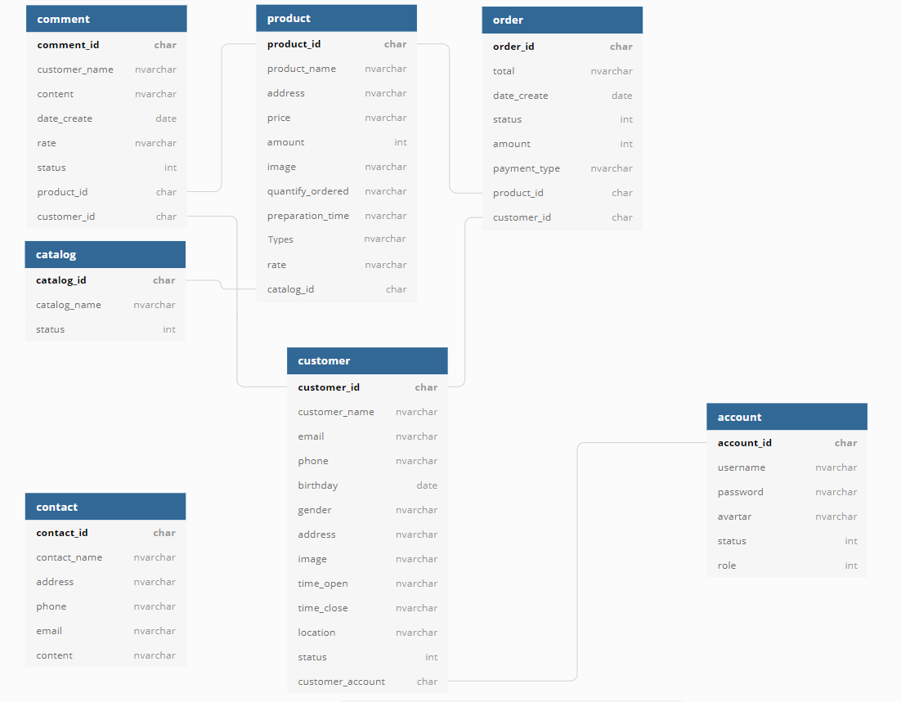

## Table Details

## Account:

|  |  |  |  |  |  |
| --- | --- | --- | --- | --- | --- |
| Attributes | Data Type | Key | Null | Default | Description |
| Account_id | Int(10) | PK | Not null |  | ID of account |
| username | Varchar(50) |  | Not null |  | Username of account |
| password | Varchar(50) |  | Not null |  | Password of account |
| Email | Varchar(100) |  |  |  | Email of account |
| Avatar | Varchar(50) |  |  |  | Avatar of account |
| Status | Int(1) |  |  |  | Status of account |
| Role | Int(1) |  |  |  | Role of account |

## Customer:

|  |  |  |  |  |  |
| --- | --- | --- | --- | --- | --- |
| Attributes | Data Type | Key | Null | Default | Description |
| customer_id | Int(10) | PK | Not null |  | ID of customer |
| customer_name | Varchar(50) |  | Not null |  | Name of customer |
| Images | Varchar(50) |  | Not null |  | Images of customer |
| email | Varchar(50) |  |  |  | Email of customer |
| phone | Varchar(50) |  |  |  | Phone of customer |
| birthday | Varchar(50) |  |  |  | Birthday of customer |
| gender | Varchar(50) |  |  |  | Gender of customer |
| address | Varchar(50) |  |  |  | Address of customer |
| Time_open | Varchar(50) |  |  |  | Time open of customer |
| Time_close | Varchar(50) |  |  |  | Time close of customer |
| Location | Varchar(50) |  |  |  | Location of customer |
| Status | Int(1) |  |  |  | Status of customer |
| Account_id | Int(10) | PK | Not null |  | ID of account |

## Catalog:

|  |  |  |  |  |  |
| --- | --- | --- | --- | --- | --- |
| Attributes | Data Type | Key | Null | Default | Description |
| catalog_id | int(10) | PK | Not null |  | ID of catalog |
| catalog_name | nvarchar(50) |  | Not null |  | Name of catalog |
| Status | Int(1) |  |  |  | Status of catalog |

## Product:

|  |  |  |  |  |  |
| --- | --- | --- | --- | --- | --- |
| Attributes | Data Type | Key | Null | Default | Description |
| product_id | int(10) | PK | Not null |  | ID of product |
| product_name | nvarchar(50) |  | Not null |  | Name of product |
| Price | varchar(50) |  | Not null |  | Price of product |
| Amount | int(10) |  | Not null |  | Amount of product |
| Images | Varchar |  | Not null |  | Images of product |
| Quantify_ordered | int(10) |  | Not null |  | Q.Ordered of product |
| Preparation_time | varchar(50) |  | Not null |  | P.time of product |
| Rate | varchar(10) |  | Not null |  | rate of product |
| Catalog_id | int(10) | FK | Not null |  | ID of catalog |
| Customer_id | int(10) | FK | Not null |  | ID of customer |
| Types | Char(4) | PK |  |  | Types clothes of weather |

## Order:

|  |  |  |  |  |  |
| --- | --- | --- | --- | --- | --- |
| Attributes | Data Type | Key | Null | Default | Description |
| order_id | int(10) | PK | Not null |  | ID of order |
| Total | double |  | Not null |  | Total of order |
| Status | varchar(50) |  | Not null |  | Status of order |
| amount | int(10) |  | Not null |  | Amount of order |
| Payment | varchar(50) |  | Not null |  | Payment of order |
| Date_create | datetime |  | Not null |  | D.create of order |
| Product_id | int(10) |  | Not null |  | ID of product |
| Customer_id | int(10) |  | Not null |  | ID of customer |

## Contact:

|  |  |  |  |  |  |
| --- | --- | --- | --- | --- | --- |
| Attributes | Data Type | Key | Null | Default | Description |
| contact_id | int(10) | PK | Not null |  | ID of Contact |
| Contact_name | varchar(50) |  | Not null |  | Name of contact |
| address | nvarchar(50) |  | Not null |  | Address of Contact |
| Phone | varchar(15) |  | Not null |  | Phone of contact |
| Email | varchar(50) |  | Not null |  | Email of Contact |
| Content | text |  | Not null |  | Content of Contact |

## Comment:

|  |  |  |  |  |  |
| --- | --- | --- | --- | --- | --- |
| Attributes | Data Type | Key | Null | Default | Description |
| Comment_id | int(10) | PK | Not null |  | ID of comment |
| Content | text |  | Not null |  | Content of comment |
| Date_create | datetime |  | Not null |  | D.create of comment |
| Rate | int(1) |  | Not null |  | rate of comment |
| Status | int(1) |  | Not null |  | Status of comment |
| Product_id | int(10) |  | Not null |  | ID of product |
| Customer_id | int(10) |  | Not null |  | ID of customer |